**My Review**

I have been approached to make a site utilizing Dreamweaver. The site was about me. I have been given a format from the instructor and I just needed to change the foundation tone and different things to make my site unique and extraordinary. I have changed foundation tone, pictures and add my data in the site. I additionally made my own logo and connected it to my index page. I have added different pages so I can write more on me, my college and my course.

The list page is the main page telling who I am and making sense of what will be in different pages. I added a Welcome flag and a few data about me and my site. I likewise made connections to different pages.

The second page is About me. In that page you will get to know me better. I added an About me standard. I likewise added picture of the nation where I am from and the college I am currently attending. In this page I connected different pages too. I likewise connected the logo with the landing page so at whatever point you need you can simply tap the logo and go again to the Index page.

The Being coordinated page is my third page. In that page you will see my most memorable Unit data. I added a Being Organized pennant and pictures of my work. You will likewise see the work and the errands I finished. I likewise put my Word record so you can perceive how could I accomplish the work. Additionally, in this page I connected the logo to the landing page and connected different pages so you can explore simpler through my site.

The fourth page is Development Plan. In that page you will be introduced to my subsequent Unit. I finished basically everything and the work that I was given to finish. I added pictures of my work and a Word report to go through the work I did. I additionally put a logo on my Development Plan. As in different pages I connected the logo to the landing page and different pages together so you can find all the data you really want.

The Presentation page is the fourth page I did. In that page you will go through my third Unit that I did. I added Presentation standard and pictures in this page also. I likewise putted some data about the unit. You can go through one of the introductions I did. I connected my logo to the homepage page and different pages together.

The other page is the Creating a website. That is my fifth page of my site. In that page you can go through my other units.

**Things that were good**

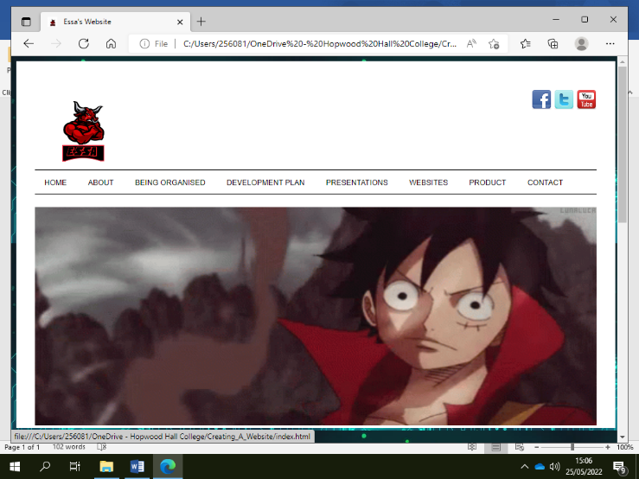The background it was related to my course and was presentable and it was what I liked and I also put videos in and on the contact page I put a form to contact me which I learned by watching a video on YouTube. The other thing I liked about the website was making my own logo I used an app on my phone to create it then saved it to my one drive and then inputted it in to my website.

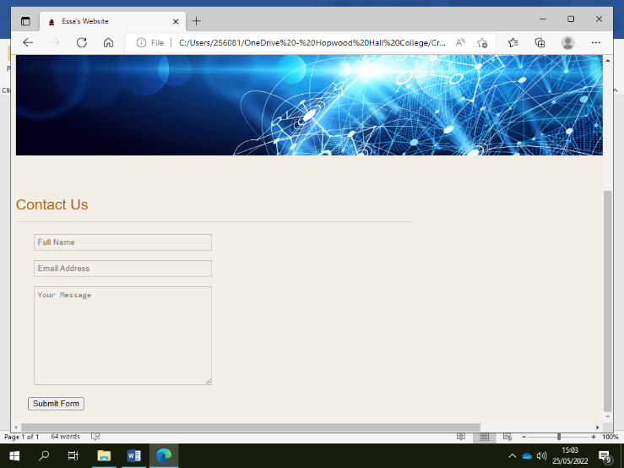

The coding to put links was tricky to do because the link wasn’t working for my twitter logo because the code wasn’t right and then I had to fix it by changing the code a bit then the problem was resolved.

One of the banners should be different because it’s not professional because this is a website for a client and instead there should be a different banner that is appropriate for the website. Also, I should change the background because it’s hard to read the text on the website so the client might not be able to read it properly so the background is not suitable for the website.